DJANGO UNCHAINED

By

Siddarth Naik

Sai Balaguru Ganess

V. Jahnavi Reddy

Swetha Vemparala

# INTRODUCTION:

The aim of this project is to traverse through a list of tables which are interlinked through a primary key and then print the columns required from the last table. Using the attributes of first table, which are not primary keys, we search for a table which has the non-key attributes of first table as the primary key of second table. Here, finding this new table is a task since we are also running a piece of code to find its location.

### SQLITE3:

SQLITE is a [relational database management system](https://en.wikipedia.org/wiki/Relational_database_management_system) (RDBMS) contained in a [C](https://en.wikipedia.org/wiki/C_(programming_language)) [library](https://en.wikipedia.org/wiki/Library_(computer_science)). In contrast to many other database management systems, SQLite is not a [client–server](https://en.wikipedia.org/wiki/Client%E2%80%93server) database engine. Rather, it is embedded into the end program.

SQLite is [ACID](https://en.wikipedia.org/wiki/ACID)-compliant and implements most of the [SQL](https://en.wikipedia.org/wiki/SQL) standard, generally following [PostgreSQL](https://en.wikipedia.org/wiki/PostgreSQL) syntax. However, SQLite uses a dynamically and weakly [typed](https://en.wikipedia.org/wiki/Data_type) SQL [syntax](https://en.wikipedia.org/wiki/Syntax) that does not guarantee the [domain integrity](https://en.wikipedia.org/wiki/Data_integrity#TYPES). This means that one can, for example, insert a string into a column defined as an integer. SQLite will attempt to convert data between formats where appropriate, the string "123" into an integer in this case, but does not guarantee such conversions, and will store the data as-is if such a conversion is not possible.

SQLite is a popular choice as [embedded database](https://en.wikipedia.org/wiki/Embedded_database) software for local/client storage in [application software](https://en.wikipedia.org/wiki/Application_software) such as [web browsers](https://en.wikipedia.org/wiki/Web_browser). It is arguably the most widely deployed [database engine](https://en.wikipedia.org/wiki/Database_engine), as it is used today by several widespread browsers, [operating systems](https://en.wikipedia.org/wiki/Operating_system), and [embedded systems](https://en.wikipedia.org/wiki/Embedded_system) (such as mobile phones), among others. SQLite has [bindings](https://en.wikipedia.org/wiki/Language_binding) to many programming languages.

## SOURCE CODE:

import pandas as pd

import sqlite3

Here we are importing pandas and SQLITE3.

con = sqlite3.connect("chinook.db")

cur = con.cursor()

query = """ Select name from sqlite_master where type = "table" """

Here we are establishing the connection with the database and selecting the table names present in the database and also creating a cursor to get the data.

res = cur.execute(query)

list_tables = res.fetchall()

Here we are executing the query and fetching the data that is in the cursor and putting all the table names into the list.

list_tables

Viewing the list.

table_name_columns = {}

for t_name in list_tables:

q1 = 'SELECT * FROM {}'.format(str(t_name[0]))

cursor = con.execute(q1)

temp1 = []

for i in range(len(cursor.description)):

temp1.append(cursor.description[i][0])

table_name_columns[str(t_name[0])] = temp1

Here we are creating a dictionary and inserting the column names of each table into the dictionary.

table_name_columns

Viewing the dictionary.

name_col = table_name_columns['playlists'][0]

for key in table_name_columns.keys():

if name_col in table_name_columns[key]:

new_table = key

Here we are searching for the non-key attributes of the table and searching for the table which has this non-key attribute as the primary key. Thereby, we are creating a new table and inserting this searched attribute in it as a primary key.

new_table

Viewing the table.

q2 = "select * from {}".format(new_table)

cur2 = con.execute(q2)

playlist_track = cur2.fetchall()

Here we are fetching the new_table values.

id = [1,3,5,8]

track_id = {}

for j in id:

counter = 0

temp = []

for i in range(len(playlist_track)):

if playlist_track[i][0] == j:

if(counter!=10):

counter+=1

temp.append(playlist_track[i][1])

else:

break

track_id[j] = temp

Here we are creating a dictionary in which the keys are taken from the playlist and each playlist has ten track_ids which are the values and are kept in a list.

track_id

Viewing the track_id dictionary.

name_col1 = table_name_columns['playlist_track'][1]

for key in table_name_columns.keys():

if name_col1 in table_name_columns[key] and key != 'playlist_track':

new_table1 = key

We are creating a new table which is going to accommodate the non-key attribute of previous table as the primary key.

new_table1

Viewing the table.

q3 = "select * from {}".format(new_table1)

cur3 = con.execute(q3)

tracks = cur3.fetchall()

tracks

Here we are fetching all the values from tracks and viewing.

track_name = {}

for id in track_id.keys():

for i in track_id[id]:

for j in range(len(tracks)):

if tracks[j][0] == i:

track_name[i]=[tracks[j][1],tracks[j][2]]

Creating a dictionary that has track_id as the key and track_name, album_id as the values.

track_name

Viewing the dictionary.

name_col2 = table_name_columns['tracks'][2]

**for** key **in** table_name_columns.keys():

**if** name_col2 **in** table_name_columns[key] **and** key != 'tracks':

new_table2 = key

Here we are finding the album_id by traversing from tracks to the album table.

new_table2

Viewing albums table.

q4 = "select * from {}".format(new_table2)

cur4 = con.execute(q4)

albums = cur4.fetchall()

To fetch the contents of table albums

albums

viewing albums

for id in track_name.keys():

for j in range(len(albums)):

if albums[j][0] == track_name[id][1]:

track_name[id].append(albums[j][1])

track_name[id].append(albums[j][2])

With album_id, we are fetching album_name and artist_id

track_name

Viewing track_name

name_col3 = table_name_columns['albums'][2]

for key in table_name_columns.keys():

if name_col3 in table_name_columns[key] and key != 'albums':

new_table3 = key

Getting artist_name from artist_id

new_table3

q5 = "select * from {}".format(new_table3)

cur5 = con.execute(q5)

artists = cur5.fetchall()

Creating a new table and fetching all

artists

Viewing contents of artists

for id in track_name.keys():

for j in range(len(artists)):

if artists[j][0] == track_name[id][3]:

track_name[id].append(artists[j][1])

Appending the contents of tracks to fetched values from artists

track_name

Viewing final contents of track_name

df = pd.DataFrame()

Creating a new dataframe

df['track_id'] = track_name.keys()

song_name = []

album_id = []

album_name = []

artist_id = []

artist_name = []

Creating lists for all columns

for key in track_name.keys():

song_name.append(track_name[key][0])

album_id.append(track_name[key][1])

album_name.append(track_name[key][2])

artist_id.append(track_name[key][3])

artist_name.append(track_name[key][4])

Appending the values accordingly into lists

df['Song title'] = song_name

df['Album_id'] = album_id

df['Album Name'] = album_name

df['Artist ID'] = artist_id

df['Artist Name'] = artist_name

Inserting the lists into dataframes

play_id = []

Creating new list

x = list(df['track_id'])

for i in x:

if i in track_id[1]:

play_id.append(1)

elif i in track_id[3]:

play_id.append(3)

elif i in track_id[5]:

play_id.append(5)

elif i in track_id[8]:

play_id.append(8)

Inserting values into play_id.

play_id

Viewing contents of play_id.

df.insert(0,'Playlist ID',play_id)

df

Viewing contents of data frame.

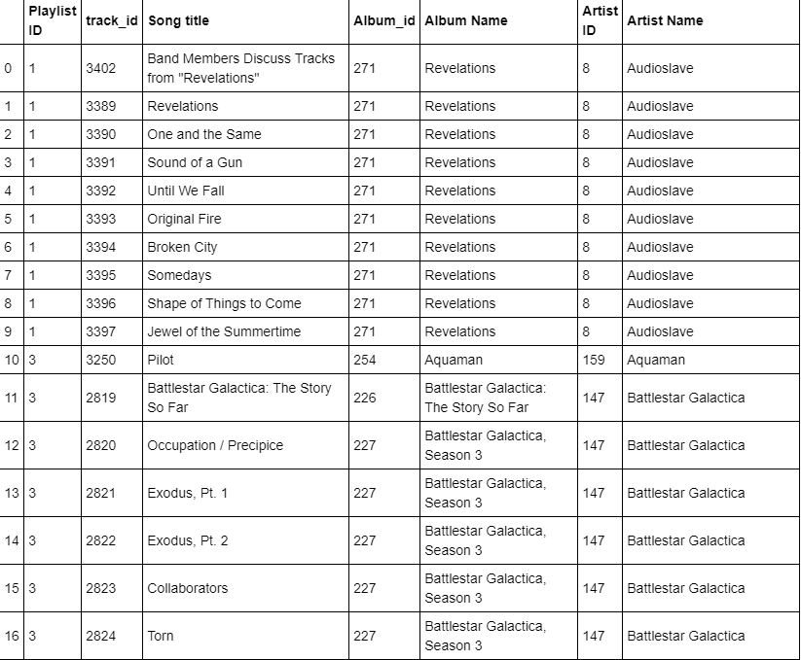

# Conclusion:

The given task has been completed and executed successfully.